**CTF Topic: IP Geolocation and Web Vulnerabilities**

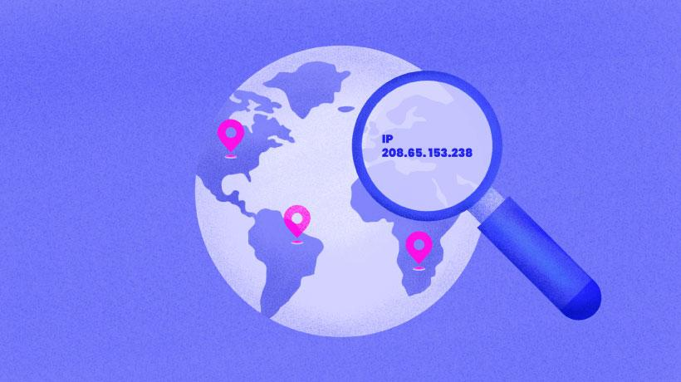

**Introduction**



IP geolocation involves determining the geographical location of a device based on its IP address. This can be useful in various security contexts, such as identifying suspicious activity or tracking down the origin of an attack. This challenge will leverage the tools available on https://www.iplocation.net/ to gather information about the target website, http://testphp.vulnweb.com/, and uncover hidden details.

**Tools and Requirements**

To perform this CTF, you will need the following tools and resources:

A web browser (e.g., Chrome)

IP Geolocation tool: <https://www.iplocation.net/>

The target website: <http://testphp.vulnweb.com/>

**Scenario**

A cybersecurity analyst, Jordan, has been assigned to investigate the target website <http://testphp.vulnweb.com/> using IP geolocation techniques. By leveraging the tools on IP Location, Jordan aims to gather detailed information about the website's IP address, physical location, ISP, and other relevant data. This information will be used to infer potential vulnerabilities and gather insights about the target website.

**Process to Perform**

**Step 1: Gather IP Information**

* Open https://www.iplocation.net/ in your browser.
* Use the "IP Lookup" tool to find the IP address of the target website http://testphp.vulnweb.com/.

**Step 2: Perform Geolocation**

* Enter the IP address of the target website into the geolocation tool to find details about its physical location, ISP, and other relevant information.

**Step 3: Analyze the Website**

* Use the IP information to infer potential vulnerabilities or interesting details about the website.
* Navigate through different sections of the target website to identify any URL patterns and parameters that might be susceptible to manipulation or reveal more information about the server.

**Let's Begin the Challenge**

With the tools and techniques outlined above, let's dive into the challenge. Use the provided tools and follow the process steps to uncover hidden information about the target website. Document each step you take and any findings along the way.

**Questions**

1. What is the country associated with the IP address of the target website?

Answer: United States

2. What is the ISP name for the IP address of the target website?

Answer: Amazon

3. What is the IP of the target website'?

Answer: 110.44.125.124

**Happy hunting!**

**Hint**

